RiverArts Festival Plein Air Event
Saturday, October 7, 2023
Haussermann Park
221 Front Street, New Richmond, OH 45157
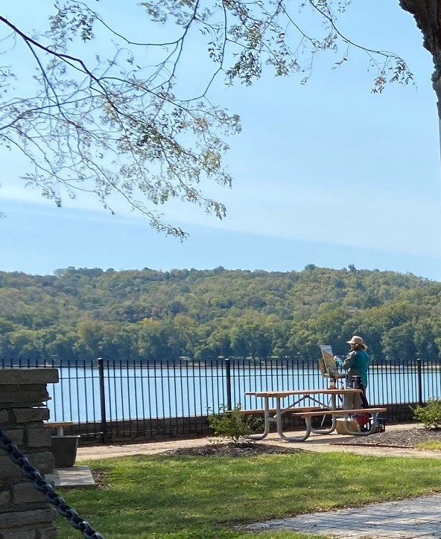

PROSPECTUS
A companion event to the juried RiverArts Festival, held during Taste of New Richmond, along with a classic car show. All artists 18 and older are welcome to participate in this outdoor painting experience. The Plein Air event is enjoying its second year accompanying RiverArts.
Haussermann Park will be available to plein air artists for the day. It is situated above the Ohio River with views of the Front St Business District, the hills of Kentucky, passing barges, anchored pleasure boats, classic cars from the car show and Taste of New Richmond food trucks.

Open registration begins June 1, 2023
To register, please contact riverartsfestivalnewrichmond@gmail.com.
Schedule
8:30 - 10:30, Check-In at Haussermann Park and canvas stamping
9 – 4 pm, Painting
4 – 4:30 pm, Judging and Awards
4:30 – 6 pm, Wet Paint Sale
Awards
1st Place $150 - 2nd Place $100 - 3rd Place $75
Online payment through PayPal
$20 via PayPal to @thenroba (the New Richmond Ohio Business Assoc is an event sponsor & allows use of their PayPal account) upon registration (or by mail to RiverArts, 1248 Bugler’s Sound Circle, Batavia, OH, 45103).
Artist Info
Artists must agree to sign, and turn in, the Artist’s Agreement at Check-In at Haussermann Park.
Access to Haussermann Park is at the intersection of Front and Walnut Streets. Artists can pull up to the barricades to unload, then find nearby street parking.
We will be stamping canvases and other substrates prior to their use. A map of the village will be provided.
All works may be For Sale, or NFS. Only artwork produced on 10/7 may be For Sale. All sales will be between the buyer and individual artists. Frames are recommended. No commission!
Follow us on Insta @riverartsfest and on Facebook @NRRiverArtsFestival

ARTIST AGREEMENT:
- No Smoking / No Pets on grounds
- All substrates will be stamped at Check In.
- All works of art must be produced on site. Leaving the event will result in disqualification.
- 90% of the work must be plein air. All painting and drawing media accepted. No photography.
- Artists may paint anywhere in the village but all artwork must contain recognizable elements from the village or views originating from same.

Name: (print) _____________________________________ Signature: ________________________________
Address: _______________________________________ City/State/Zip: ______________________________
Cell number: ______________________________ E-mail: _________________________________________

