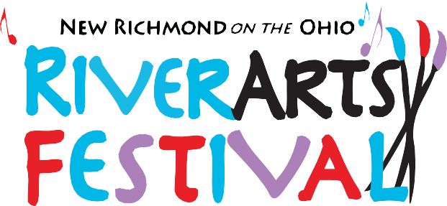

CALL TO ARTISTS!
RiverArts Festival of New Richmond, Ohio, announces a CALL TO ARTISTS!
RiverArts Festival will take place
Saturday, October 7, 2023, 12 noon - 6 pm.
RiverArts will showcase fine artists with varied work such as painting, pottery, jewelry, photography, fiber, and much more!
Come celebrate Fine Art and Music along the scenic Ohio River.
Follow us on Facebook at "RiverArts Festival in New Richmond on the Ohio" or on Instagram at “riverartsfest”!

Taste of New Richmond and a classic car show featuring over 100 cars will be taking place in New Richmond adjacent to RiverArts Festival!

The show is juried and artists are required to comply with submission guidelines which include:
- All items must be original work of the artist in concept and execution.
- Artists will provide their own 10 X 10 tents (white preferred) each leg weighted at least 25lbs (stakes allowed in addition to weights), chairs, and display equipment.
- Application constitutes a commitment for the duration of the show. (NO EARLY BREAKDOWN!)
- It is recommended that artists carry liability insurance.
- Submit 3-5 images along with the 2023 Artist Application to riverartsfestivalnewrichmond@gmail.com.
You will be notified within 7 days of jury approval.

2023 ARTIST APPLICATION
Awards include the following:
$650 - Best of Show
$250 - First Place
$200 - Second Place
$150 - Third Place
$100 – People’s Choice
Applications will be reviewed until September 9, 2023, or as long as space or category balancing allow.
Image use—By submitting an application, you are giving RiverArts permission to use images of you and your art for publicity.
NAME: ADDRESS:

CITY: STATE: ZIP: EMAIL & PHONE: WEBSITE:
DESCRIPTION OF WORK:

Show schedule is as follows:
Day of Show

8:30-11:30 Check-in and set-up 11:30 Judging
12-6 Artists and Musicians 6:00 Breakdown

Upon acceptance, please send booth fee of $95 by PayPal to @thenroba or by mail to: RiverArts Festival, 1248 Bugler’s Sound Circle, Batavia, OH, 45103. For more information, please contact riverartsfestivalnewrichmond@gmail.com.
RiverArts Festival 2023 is sponsored by
New Richmond Ohio Business Association (NROBA) and Renaissance New Richmond.

