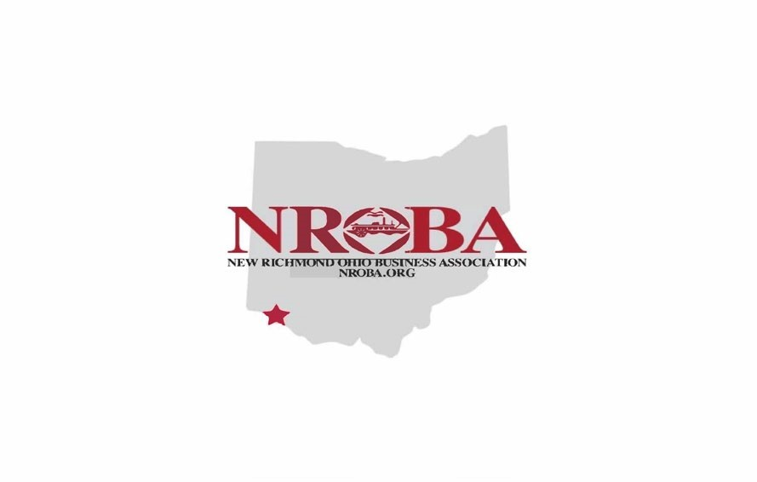
New Richmond Ohio Business Association
NROBA.org

2022 Membership Application
Company Name________________________________________ Membership: New ____ Renewal_____
Owner Name__________________________________________
Address______________________________________________
City/State/Zip__________________________________________
Phone #1__________________Phone #2____________________ Email Address_________________________________________
Please select your membership level. Dues are applied from April to April.
_____ Corporate $250
_____ Individual Business $100
_____ Individual Business $50 April, $50 May
_____ Philanthropist $35
Please remit payment:
______ PayPal to @thenroba (please add $3 for processing)
______ River Hills Bank Memo: “For membership NROBA”
Mail check to:
Melanie Sauter
1248 Buglers Sound Cir
Batavia, OH 45103

Application may be emailed to: Melanie Sauter at sauter4@roadrunner.com

Signature: ____________________________Date_____________

